- All Hail the power of Jesus’s name
- Sovereign
- Tell Them
- Speak O Lord
- Risen

All hail the power of Jesus’s name

[Verse 1]
E B
All hail the pow'r of Jesus' name!
A B E
Let angels prostrate fall;
E C#m
bring forth the royal diadem,
E B C#m F# B
and crown him Lord of all;
E B
bring forth the royal diadem,
E A E B E
and crown him Lord of all.

[Verse 2]
E B
Ye chosen seed of Israel's race,
A B E
Ye ransomed from the fall.
E C#m
hail him who saves you by his grace,
E B C#m B F# B
and crown him Lord of all;
E B
hail him who saves you by his grace,
E A E B E
and crown him Lord of all.

[Verse 3]
E B
Let ev'ry kindred, ev'ry tribe,
A B E
on this terrestrial ball,
E C#m
to him all majesty ascribe,

E B C#m F# B
and crown him Lord of all;
E B
to him all majesty ascribe,
A E B E
and crown him Lord of all.

[Verse 6]
E B
O that with yonder sacred throng
A E B E
we at his feet may fall!
E C#m
we'll join the everlasting song,
E B C#m F# B
and crown him Lord of all;
E B
we'll join the everlasting song,
E A E B E
and crown him Lord of all.

Sovereign - Chris Tomlin (Key of D)

[Intro]
D Bm G Bm A

[Verse]
D
Sovereign in the mountain air
Bm
Sovereign on the ocean floor
G
With me in the calm
Bm A
With me in the storm
D
Sovereign in my greatest joy
Bm
Sovereign in my deepest cry
G
With me in the dark
Bm A
With me at the dawn

[Chorus]
D Bm
In your everlasting arms
G
All the pieces of my life
Bm
From beginning to the end
A
I can trust you
D Bm
In your never failing love
G
You work everything for good
Bm
God whatever comes my way
A
I will trust you

VERSE

CHORUS

Bm
God whatever comes my way
A D
I will trust you

[Bridge]
D G Bm
All my hopes, all I need
A
Held in your hands
D G Bm
All my life, all of me
A
Held in your hands
D G Bm
All my fears, all my dreams
A D G Bm A
Held in your hands x3

CHORUS

G Bm
God whatever comes my way
A
I will trust you x2
G Bm
God whatever comes my way
A
I will trust you

INTRO
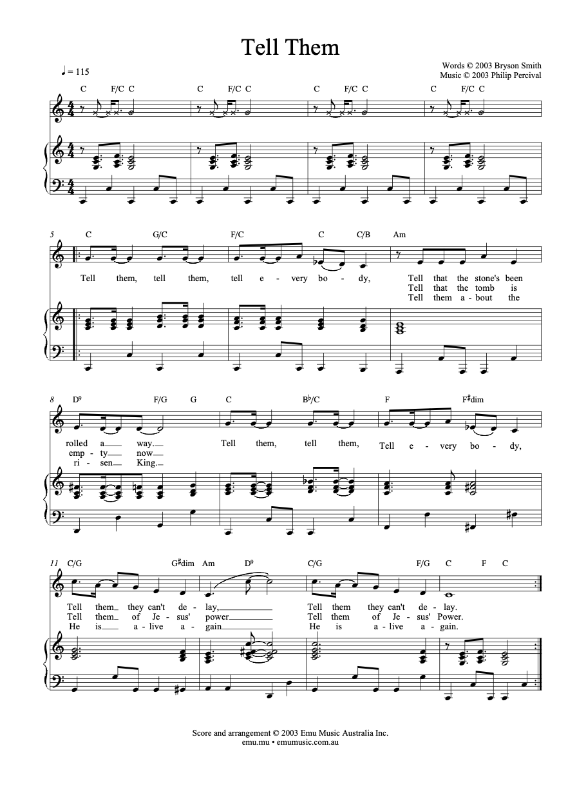
SPEAK O LORD

D E A D A/C#
Speak, O Lord, as we come to You
D A/C# F#m E
To receive the food of Your Holy Word.
D E A D A/C#
Take Your truth, plant it deep in us;
D A/C# E A
Shape and fashion us in Your likeness,
E E/D A/C# D A/C#
That the light of Christ might be seen today
E E/D A/C# D E
In our acts of love and our deeds of faith.
D E A D A/C#
Speak, O Lord, and fulfill in us
D A/C# E A
All Your purposes for Your glo ry.

D E A D A/C#
Teach us, Lord, full obedience,
D A/C# F#m E
Holy reverence, true humility;
D E A D A/C#
Test our thoughts and our attitudes
D A/C# E A
In the radiance of Your purity.
E E/D A/C# D A/C#
Cause our faith to rise; cause our eyes to see
E E/D A/C# D E
Your majestic love and authority.
D E A D A/C#
Words of pow'r that can never fail—
D A/C# E A
Let their truth prevail over unbelief.

D E A D A/C#
Speak, O Lord, and renew our minds;
D A/C# F#m E
Help us grasp the heights of Your plans for us—
D E A D A/C#
Truths unchanged from the dawn of time
D A/C# E A
That will echo down through eternity.

E E/D A/C# D A/C#
And by grace we'll stand on Your promises,
E E/D A/C# D E
And by faith we'll walk as You walk with us.
D E A D A/C#
Speak, O Lord, till Your church is built
D A/C# E A
And the earth is filled with Your glory.

Risen (Key: D, Time: 6/8)

Intro
D | G | D/A | A |

Verse 1
D A/D Bm G
Jesus, Jesus of Nazareth
D A/D Bm G (split bar)
Delivered up
D A/D Bm G
Crucified at the hands of the lawless
D A/D Bm G
But safe in the plan of God

Pre
Em G
The holy one has not seen decay
Em D C G
The grip of the grave could not contain him

Verse 2
D A/D Bm G
Servant, Holy and Righteous One
D A/D Bm G
Author of life
D A/D Bm G
Glorified by the God the fathers
D A/D Bm G
But by men denied

Pre
Em G
The promised one has suffered and died
Em D C G A
The gift of forgiveness has arrived

Chorus
D G A
Christ is risen and reigning
Bm G A
The gospel is spreading and saving
D G A Bm
The Spirit is poured out and giving new life
A G A
to us
D G A
Go and tell of the wonders of
Bm G A
God who is calling and claiming
D G A
His message is sent out and reaching the
Bm A G A
world through us

Interlude
D | G | D/A | A |

Verse 3
D A/D Bm G
Lord of all, Jesus the Son of God
D A/D Bm G
Good news of peace
D A/D Bm G
Nailed to a tree, now we have witnessed him
D A/D Bm G
Raised up and free

Pre
Em G
Anointed with the Spirit and power
Em D A
Appointed to be judge of all the world
Em G
He's the one the prophets spoke about
Em D C G A
Keeping every promise, every word

CHORUS

Epilogue
D G A Bm
We will be your witnesses
Bm G A D
We will testify to the end
D G A Bm
We will revel in the shame
Bm G A D
As we suffer for your name
D G A Bm
You will finish what you start
Bm G A D
You will open rebel hearts
D G A Bm
You're the one they crucified
Bm A G Em D
But God has made you Lord and Christ

Sovereign - Chris Tomlin (Key of D)

[Intro]
D Bm G Bm A

[Verse]
D
Sovereign in the mountain air
Bm
Sovereign on the ocean floor
G
With me in the calm
Bm A
With me in the storm
D
Sovereign in my greatest joy
Bm
Sovereign in my deepest cry
G
With me in the dark
Bm A
With me at the dawn

[Chorus]
D Bm
In your everlasting arms
G
All the pieces of my life
Bm
From beginning to the end
A
I can trust you
D Bm
In your never failing love
G
You work everything for good
Bm
God whatever comes my way
A
I will trust you

VERSE

CHORUS

Bm
God whatever comes my way
A D
I will trust you

[Bridge]
D G Bm
All my hopes, all I need
A
Held in your hands
D G Bm
All my life, all of me
A
Held in your hands
D G Bm
All my fears, all my dreams
A D G Bm A
Held in your hands x3

CHORUS

G Bm
God whatever comes my way
A
I will trust you x2
G Bm
God whatever comes my way
A
I will trust you

INTRO

